Rittal and Eplan at “The Smarter E Europe” 2024
“Electrify Your System!”: Achieving an all-electric society more quickly with Industry Standards
Herborn/Monheim, 3 June 2024
To achieve the objective of the all-electric society more quickly, greater speed is needed to implement energy transition solutions. Digitalisation, standardisation and automation are key, especially when skilled workers are rare. At The Smarter E Europe exhibition in Munich (in Hall B5, Booth 110), Rittal and Eplan will demonstrate how the intelligent combination of software and hardware is pushing energy transition forward. Consistent data and standards are helping users in the fields of generation, e-mobility, distribution and storage to increase their efficiency and productivity.
With the exhibition motto of “Creating the new Energy World”, The Smarter E Europe 2024, being held in Munich from 19 to 21 June, showcases the opportunities and requirements of the energy transition. The aim is to sustainably electrify more and more applications in our everyday economic and social lives and to create the necessary energy infrastructure to this end. At their booth under the slogan “Electrify Your System!”, Rittal and Eplan will show how the conversion and expansion of power grids and decentralised energy systems can be speeded up. Control and switchgear manufacturers, system integrators, OEMs and operators can learn how they can seriously improve their value-added processes and cut project lead times by at least 30%.
Gaining momentum through industry standards
“Expanding energy systems is about speeding up the value creation processes. We are achieving this by increasing the level of digitalisation and standardisation, similar to what is already practised in mechanical engineering every day,” says Raphael Görner, Head of Rittal’s Energy & Power Solutions Business Unit. This is being demonstrated at the booth based on the example of a compact transformer station: “Eplan offers an end-to-end Industry Standard Project as a pre-designed solution, including the operating equipment list required in the energy sector. This is how we are establishing an industry standard that can be easily customised if needs be,” explains Jan Oliver Kammesheidt, Global Vertical Market Manager Energy at Eplan. The project's data record contains all the information for modular Rittal system technology and components from many other manufacturers from the Eplan Data Portal. Customers benefit from significantly less work and time, lower costs, standards-compliant designing with automated planning features and a digital twin for operation. Other projects planned for the booth include an AC distributor for photovoltaics and a power distributor for charging parks.
Power distribution on a new level
There is also considerable optimisation potential for energy transition applications by improving power distribution system technology: That’s why visitors to the booth will be given a preview of RiLineX, a new 60-mm busbar system platform. RiLineX sets a new standard in the field of power distribution. The system has been redesigned not only to raise the speed and safety of engineering and assembly to a new level. Rittal is also consistently pursuing the platform approach. Manufacturers of devices and components receive the interface data they need to develop the appropriate components.
Partnership project for standardised charging pillars
Rittal and the charging infrastructure company EcoG will also show how to speed up the expansion of charging pillars and charging parks. A “Power Block” is being presented as an exhibit with bayable CS Toptec outdoor enclosures, whereby Rittal’s system expertise is combined with EcoG’s software and charging station components. The Power Block thus embodies the joint project plan to standardise central, back-end infrastructure for charging parks and so greatly speed up the expansion of this important element of the energy transition.

Eplan, Rittal and Weidmüller: End-to-end processes for the energy transition
Eplan and Rittal, along with Weidmüller, are showing how data consistency drives the scaling of enclosures for the energy transition infrastructure. At the booth, they are showing how planning is performed with product data, using Eplan Data Standard (EDS) or using project templates. This planning data is seamlessly enriched in the Weidmüller Configurator (WMC) and then transferred to the workshop using interfaces without any media discontinuity so that the hardware components can be smoothly installed.

4688 characters

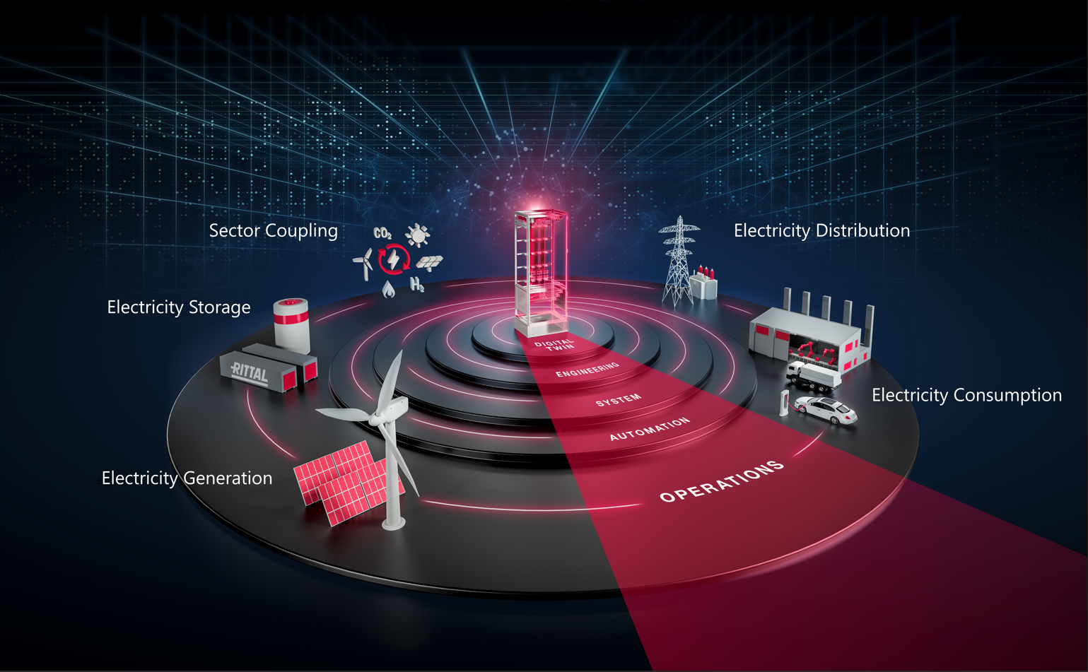 |  | 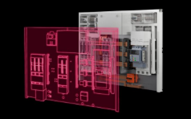
Image 1: The aim is to electrify more and more applications in our everyday economic and social lives and to create the necessary energy infrastructure for this. |  | Image 2: “Expanding energy systems is about speeding up the value creation processes. We are achieving this by increasing the level of digitalisation and standardisation, similar to what is already practised in mechanical engineering every day.,” says Raphael Görner, Head of Rittal’s Energy & Power Solutions Business Unit.

May be reproduced free of charge. Please name Rittal GmbH & Co. KG / Eplan GmbH & Co. KG as the source.

Rittal

Rittal is a leading global supplier of enclosure systems, automation and infrastructure with its industrial, IT, energy and power, cooling and service units. Rittal products and solutions are used in over 90% of global industries – standardised, customised, and always of the very best quality.
Our approach and methodology: Rittal, Rittal Software Systems (Eplan, Cideon and German Edge Cloud) and Rittal Automation Systems (RAS, Ehrt, Alfra) combine their hardware and software expertise to streamline, optimise and digitalise processes across the entire value chain for our customers including their IT infrastructure – from control and switchgear construction, machine building to factory operators or the energy sector.
Our delivery promise: Rittal standard products are delivered in Germany within 24 hours, and within 48 hours throughout Europe.
Customer focus
Improving efficiency and increasing productivity through automation and digitalisation is one of the biggest challenges for our customers. This requires in-depth knowledge and expertise, the combination of hardware and software, and cross-sector networking. We are convinced that creating and connecting data rooms is crucial to the success of industrial transformation. And that is exactly our speciality and field of competence.
Eplan and Rittal are driving the development of the digital automation twin, making data accessible and useable in operations as well. Cideon is improving data consistency in the digital product twin context with its CAD/CAM, PDM/PLM and product configuration expertise. German Edge Cloud’s ONCITE Digital Production System (DPS) makes production process data transparent, enabling it to be optimised – right through to energy management using digital production twins.
Sustainability
Environmental and climate protection, social commitment and ethical corporate management are a given for Rittal. We take our responsibility for a sustainable future seriously. Our approach to resource management and conservation involves continuous improvement of our production processes and ensuring that our products have the lowest possible Product Carbon Footprint. Our solutions support our customers in achieving their climate targets.
Family business and global player
Founded in 1961, Rittal is the largest company in the owner-operated Friedhelm Loh Group. The group operates worldwide, with 12 production sites and 95 international subsidiaries. It has 12,100 employees and posted revenues of 3 billion euros in fiscal 2023. In 2023, the Friedhelm Loh Group was presented with the “Best Place to Learn” and “Employer of the Future” awards. In 2024, Rittal was awarded the Top 100 Seal as one of Germany’s most innovative medium-sized companies for the third time in a row.
For more information, visit www.rittal.com and www.friedhelm-loh-group.com.

Corporate Communications
Dr. Carola Hilbrand Rittal GmbH & Co. KG
Corporate & Brand Communications Auf dem Stützelberg
Phone: 02772/505-2527 35745 Herborn
hilbrand.c@rittal.de www.rittal.com


Follow us:
Eplan

Eplan provides design, planning and engineering software and service solutions for all aspects of electrical, automation and mechatronic engineering. The company has developed one of the world’s leading design software solutions for machine and panel builders. Eplan is also the ideal partner to simplify and streamline complex and challenging engineering processes.
Both standardised, as well as customer-specific interfaces to ERP and PLM/PDM systems, ensure data consistency across the entire value chain. Working with Eplan means seamless communication across all engineering disciplines. Regardless of whether the company is large or small: It allows customers to use their expertise more efficiently. Worldwide, EPLAN serves and supports over 68,000 customers. Together with its customers and partners, EPLAN strives to continue growing and actively advancing integration and automation in engineering. Within the Eplan Partner Network, open interfaces and seamless integrations are implemented together with partners. “Efficient engineering” is Eplan’s core focus.
Eplan was founded in 1984 and is part of the owner-operated Friedhelm Loh Group. The group operates worldwide, with more than 12 production sites and over 95 international subsidiaries. It has more than 12,100 employees and posted revenues of 3 billion euros in fiscal 2023. In 2023, the Friedhelm Loh Group was presented with the “Best Place to Learn” and “Employer of the Future” awards.
For more information, visit www.eplan-software.com and www.friedhelm-loh-group.com.

Corporate Communications
Birgit Hagelschuer Eplan GmbH & Co. KG
Press- and public relations An der alten Ziegelei 2
Phone: 02173 3964-180 40789 Monheim am Rhein
Hagelschuer.b@eplan.de www.eplan.com

Follow us:

